TW 17

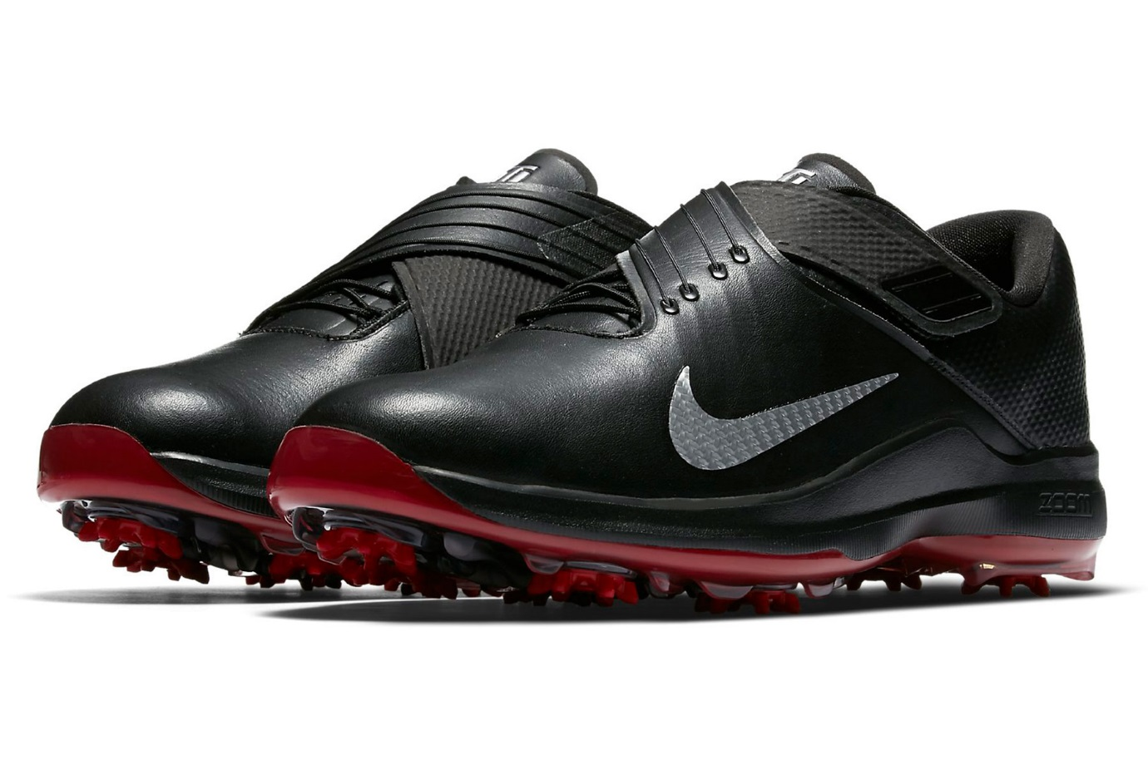

Product code: 1006

The Nike Air Zoom TW '17 Men's Golf Shoe provides lightweight, responsive cushioning and a propulsive feel underfoot for a powerful swing.

# Nike Air Zoom 90 IT

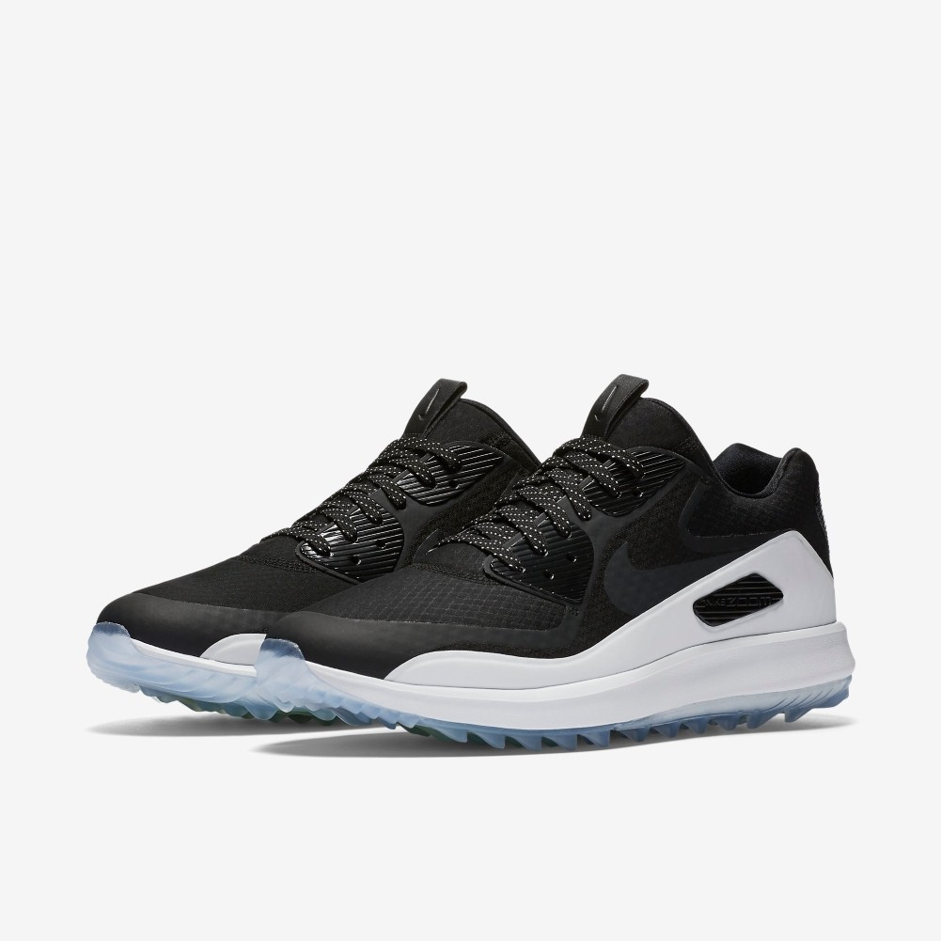

Product code: 1007

An updated favourite of Rory McIlroy's, the Nike Air Zoom 90 IT Men's Golf Shoe features a waterproof upper and incredible traction for those who don't let the weather stand in their way.

# Nike Lunar Command 2

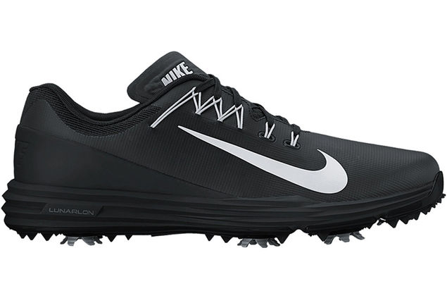

Product code: 1008

The Nike Lunar Command 2 Men's Golf Shoe features Flywire technology for an exceptionally secure fit and lightweight cushioning that keeps you in total comfort from the first hole to the last.

# Nike Lunar Control Vapor 2

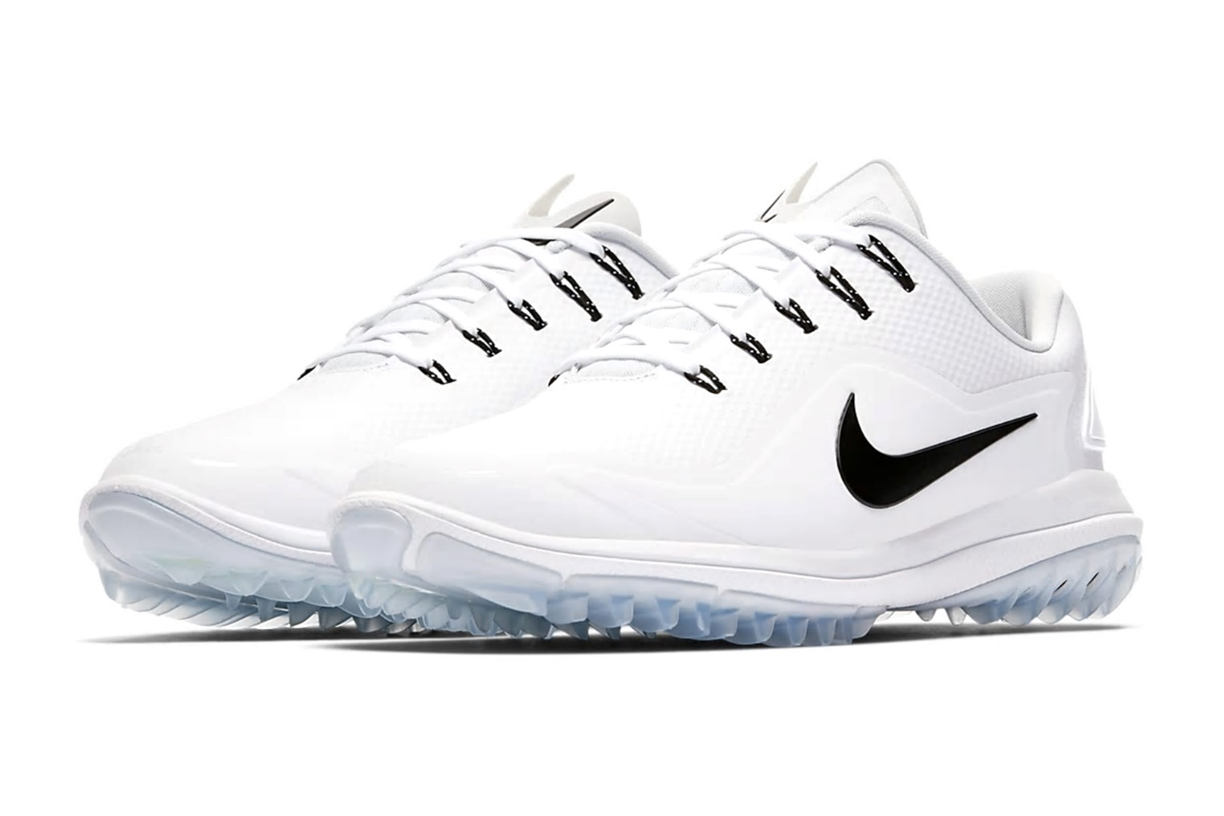

Product code: 1009

The Nike Lunar Control Vapor 2 Men's Golf Shoe delivers the grip, support and comfort you need to drive further off the tee.

# Nike FI Flex

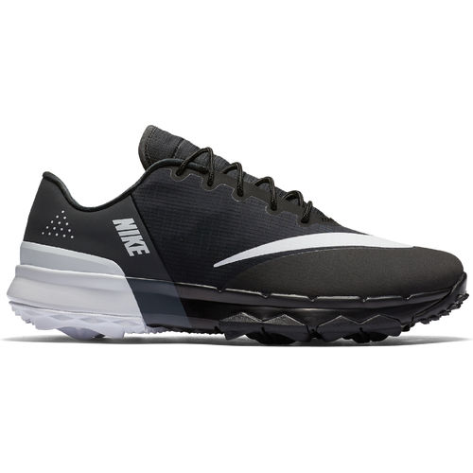

Product code: 1010

The Nike FI Flex Men's Golf Shoe flexes with your foot for a smooth, natural feel and features lightweight cushioning to help keep you comfortable through to the eighteenth hole.